Ansible version—2.0.0.2 (installation guide –cheetsheet)
1) Why we need ad-hoc ansible commands, scenario where you have used ansible ad-hoc command?
When you install ansible by default /usr/bin/ansible installed,ad-hoc command usually use if you are copy something from host machine to the node or if you want to ping particular machine then you can use ad-hoc command and this things are not reusable like if you want to execute the task again you need execute that command again 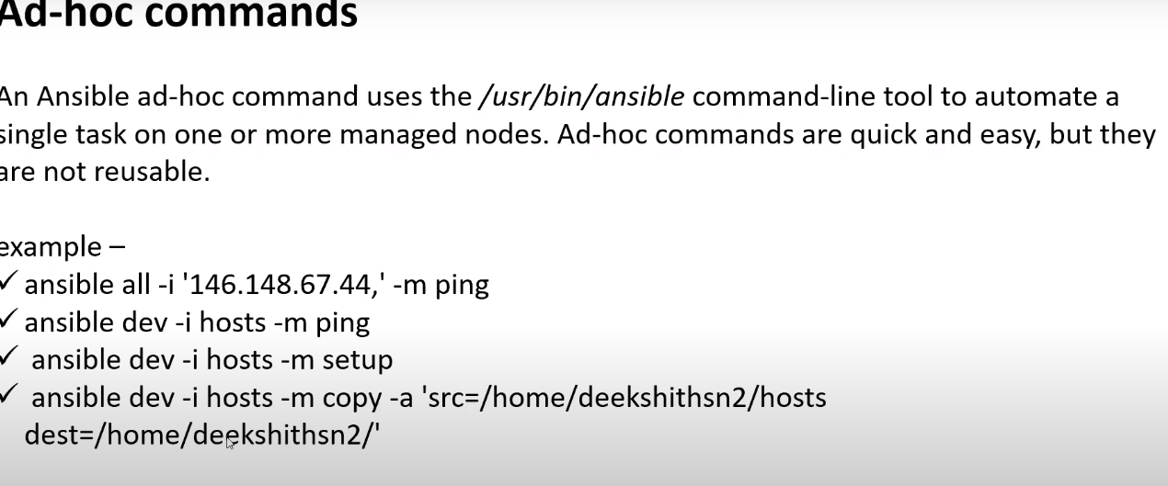
2) When i need detailed logs on executing ansible playbook what option i need to use? Repo-Ansible
3) what is ansible.cfg file?
In this file every thing bydefault commented, if you want use let say commented out inventory path in ansible.cfg then you need not to mention – I option in ad-hoc command because the path of hosts file is specified from the ansible.cfg file 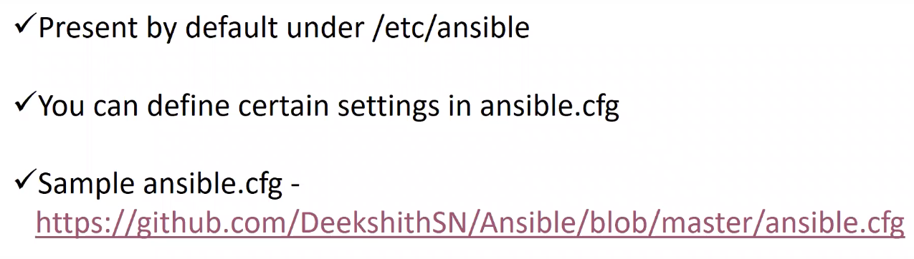
4) what are the modules have you worked on? which module will you use for getting the file from node to master? 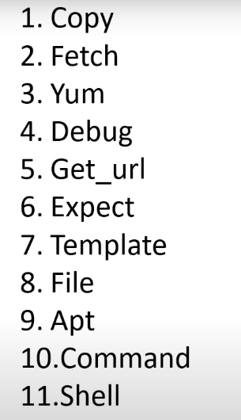
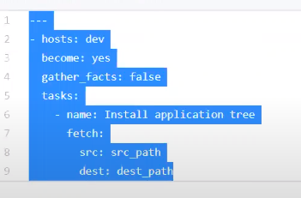
5) Lets say i have a playbook which has 5 tasks in playbook, first 2 tasks should run on local machine and other 3 tasks should run on node? (repo-Ansible -→ multiple_plays.yaml)
You can achieve this in multiple way either using when condition or block concept in playbook but one of my way is
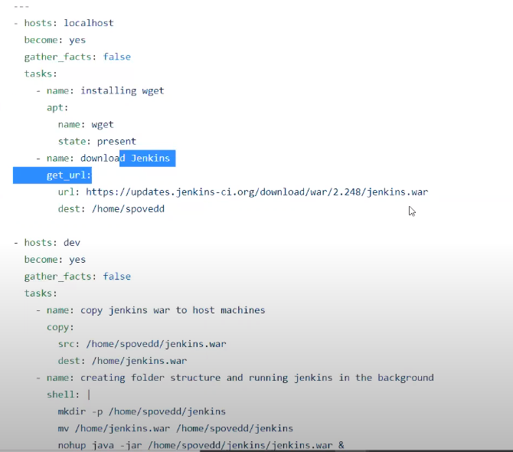
nohup and & ---run in background
6) Lets say i have 4 machines consider 1 as ansible master other 3 as nodes, what are the basic setup you need to do for ansible cluster?
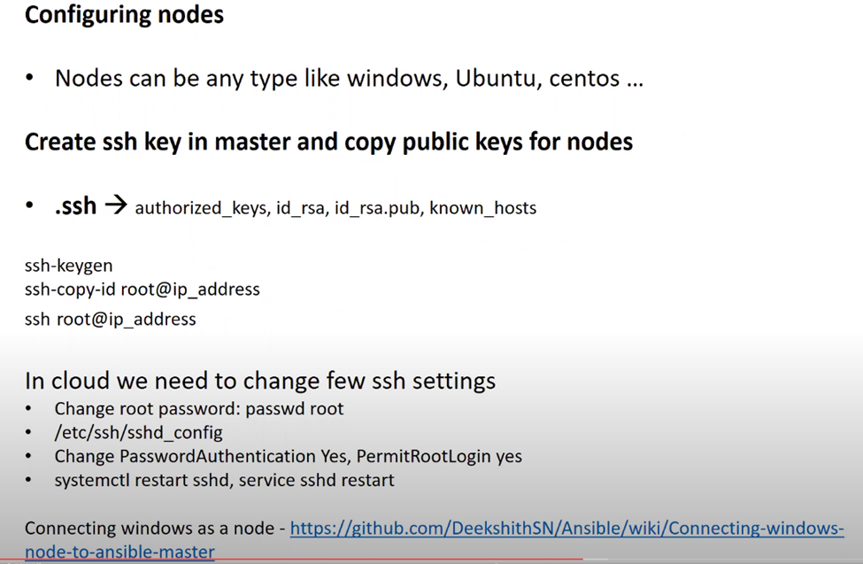
7) what are ansible roles? why we need ansible roles? have you worked on ansible galaxy? (repo—Ansible → tomcat-standalone → playbook is site.yml)
Roles are basically a reusable componant and also it say complex task in ansible that you want to devide it in multiple task make it simple like your application is handle by some one, your task is written by someone in that case you can distribute the task ( you can create a kind of folder structure you can assign that folder to the perticular task later you can reffer those roles on playbook and you can run it )
Roles are not playbook that are small independent thing that you develop it refer it in playbook 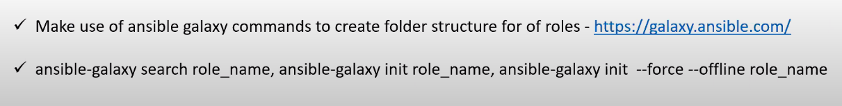 rather then createing this folder structure manullay you can use ansible galaxy

Roles---- 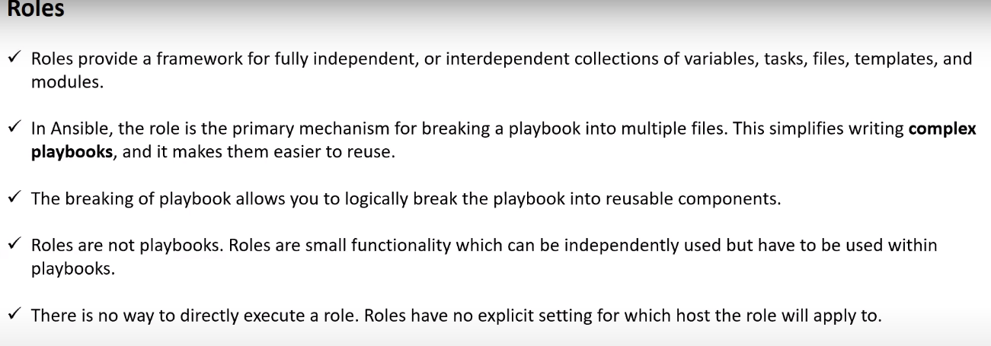
8) What are ansible facts?
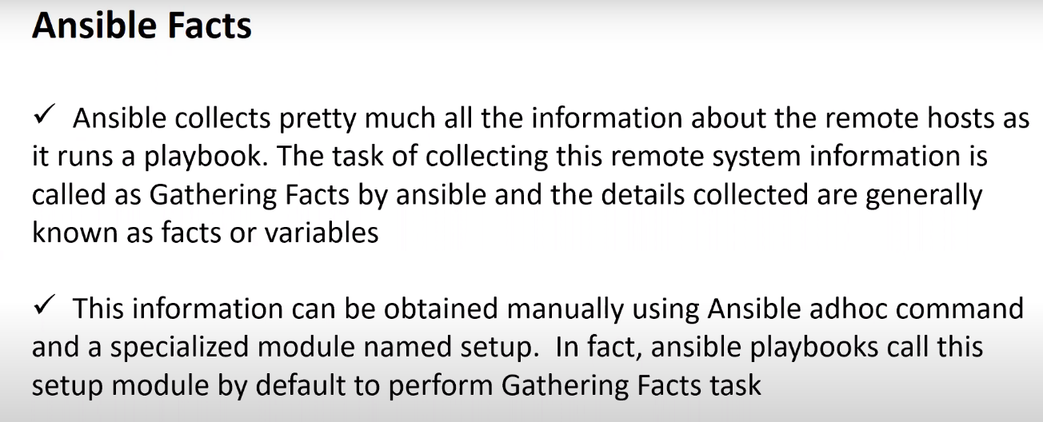
9) Can we have windows machine as ansible master? as node?have you worked on any windows modules? can you list few?any extra configuration do we need to do?
No you can’t have windows machine as ansible master but you can have it as node basically we never deal with it in practical
Configuration --- Ansible → wiki → connecting windows node to the master

10) What is the best method to make your ansible YAML files reusable?
Ans –Roles ( reusability & segregation of task)

11) What is ansible vault and ansible tower?
If you want to store any sensible information or important information you go with vault
Google -- how to create vault in ansible
if you want to schedule your ansible playbook to run in particular time then go for ansible tower
it is paid version

12) Lets say I have playbook need to be run with Root user how would you do this? 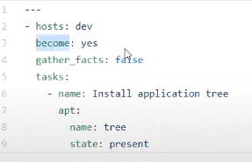
13) Difference between copy and fetch module?
The fetch module is used when you want to move files from the remote host to the local host (i.e. fetch a file from the remote host). The copy module is used when you want to put files onto the remote host, or you want to copy files to another location on the remote host.

14) Why ansible ? What makes ansible powerful than other tools like chef and puppet?
All this ansible, chef & puppet are configuration management tool let say for example I have 50 machine I want to install java an each machine if configuratin management tool are not used then you need to login each machine and install it and make sure it is installed properlly or not later you may get a requirement to install other tool also and let say you want to copy a zip file and unarchive to the all machine soo doing it manullay it will take lot of effert that’s where we automate this kind of things by using configuration management tool ( ansible have cloud module also aws related work)
Why ansible is special because – ansible has pushbasemechanisim
- Let say you have ansible host & you have nodes (20 nodes) we will gone install ansible in one of the host and we will right somrthing called playbook & we will save the information of all the nodes in hosts file soo what it will do like it will take task and exicite it in each node sequientialy so we are pushing the task from ansible host to node ( you need not to do anything in client side just have a ssh connectivity between server and client)but in other tool like chef & puppet pullbased mechanism where you need to install chef in host as well as you need to install some tolls in nodes also like you need to install tools both server and client and in client side what ever the tool installed right there you need to request to the server like please send me some instructions to install java and request is responding back from server
- Ansible is written by the python that’s why it is faster then chef and puppet and
- we will use yaml formate in ansible it is simple but in chef and pupppet different syntex altogether you need to do
- in ansible communication mediuam is SSH and other tool it uses SSL as communication medium

15) 5 modules that you have worked on? Can we create custom module ?
Yes we can create custom module in ansible just go witth documentation
16) What is dynamic inventory in ansible?
When you mostly work with the cloud that time you come across with this dynamic inventory
Let say you 10 machine in aws this mahines ip is mentined in hosts of ansible but this ip are not static (because some machine will gose down) in that situation the changed ip information should get it in the hosts that’s where dynamic inventory come into the picture it will have python script it will gone a help as it will communicate with cloud provider get the information of client host and place it inn hosts file in server

17) Lets say I have both Ubuntu and centos machines as nodes I want install application tree using same playbook, how would you approach this scenario? (Repo—Ansible→ run_based_os.yaml)
For this we use factvariable 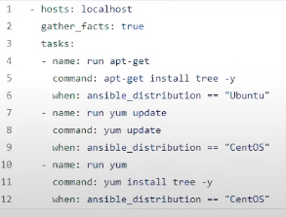
18) How to handle prompts with ansible playbook?
Let say you created user pavan and you want to update the passwd of pavan by using ansible playbook but in that they will ask enter the passwd I want to answer that, I want to automate that prompt it self there is something called except module in ansible
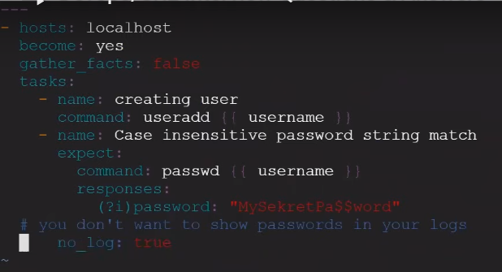
Before passwor it may any word →(?i)

19) What is ansible galaxy?
It is a repository where in like to have standard roles where you want to use that in the project we can download that can use it there is also publicly available roles you download and use that

20) What are adhoc commands
21) What are handlers and notify in ansible playbook

